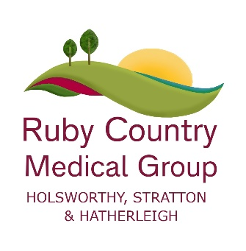
How to apply for and receive your COVID Pass when you’re unable to be vaccinated

A carer can apply on your behalf.
1. Phone the NHS COVID Pass service on 119 to ask for an NHS COVID Pass medical exemptions application form.You can also call to find out more information about NHS COVID Pass medical exemptions.
The call handler at the NHS COVID Pass service will ask you some questions. You will need to give:
- your name
- your date of birth
- your NHS number (if you know it)
- the name of your GP and/or specialist clinician
2. If you’re eligible to apply, you’ll get an application form by post. You should not ask your GP for an application form. If you do go to your GP before you get your application form you’ll be asked to call the NHS COVID Pass service on 119.
3. Return your application form to the GP or relevant clinician stated on the form.Your application will be clinically reviewed by your doctor, specialist or midwife. Your GP, specialist or midwife may ask to speak with you if needed, but you won’t need to book this when you submit your application.
4. You’ll automatically get the results of your application by post once your application has been processed. You don’t need to contact your GP or the clinician reviewing your exemption unless they ask you to contact them.
5. If you get a medical exemption you can use the domestic NHS COVID Pass wherever you need to. The pass won’t show others that you have a medical exemption, just that you have the NHS COVID Pass. You can access your NHS COVID Pass digitally – on the NHS app or the NHS website. You can also download it as a pdf. To request a paper version of your pass, call 119. Find out more about the NHS COVID Pass on the NHS website.
6. The clinical decision on your medical exemption is final. You can’t appeal the decision.
Receiving an exemption does not mean you are protected against COVID-19. You should self-isolate if you have any symptoms of COVID-19.

