**MaPS SW Stakeholder Monthly**

**March 2025**

**Illegal Lending: Loan Sharks**

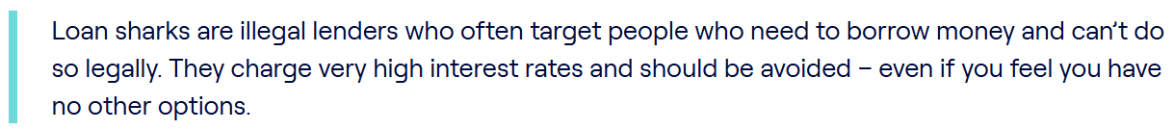

**Facts - Loan sharks and the Law**

* Any lender, authorised or not, who harasses you is breaking the law.
* Some loan sharks will threaten you by saying you’ll be prosecuted and even sent to prison if you don’t pay them. This can’t happen.
* An unauthorised lender such as a loan shark doesn’t have the legal right to make you pay back the loan at all. This is because the loan itself is illegal.
* If you’ve been approached by someone you think is a loan shark, contact the police. Call 999 if you’re in immediate danger.
* Loan sharks will never stop chasing you for money, so it’s important you act as soon as possible. Anything you tell the police will be confidential and you can remain anonymous.



**Facts - Reporting a Loan Shark**

* If you’ve found out that a lender is a loan shark, you can report them anonymously. You can either call or make a report online if you’d prefer not to talk to someone:
* If you live in England, you can report them to the Stop Loan Sharks team by calling 0300 555 2222 or visit Stop Loan Sharks

**Facts - Signs that someone who has offered to lend you money is a loan shark**

It’s important to avoid borrowing from people who you don’t know well, such as colleagues, friends of friends, or people you recognise in your local community or faith group. This is because they could be a loan shark. Here are some of the signs to look out for if you think you might be borrowing from a loan shark:

* No paperwork – paperwork makes something seem more legitimate, and loan sharks avoid.
* Cash loans or bank transfers – although more loan sharks are now using bank transfers, they usually prefer to deal with cash.
* Refusing to give you information about the loan – most loan sharks will avoid giving you clear details about your loan, such as the interest rate, details of previous repayments and the total amount you owe.
* Taking possessions for security – some loan sharks will take personal possessions as security, such as your passport or bank cards.
* Your loan is getting bigger – loan sharks might increase the debt or add extra charges at any time, even if you’re making regular payments.
* Threats of violence – loan sharks often use intimidation and threats to frighten people into paying back the money.
* They lend to more than one person – if it’s someone you know and you’re aware that they’ve offered to lend money to other people too.
* If you’ve already borrowed from a loan shark, you haven’t broken the law and there is help available.

**Be Careful**

Payday loan companies often pay to get their adverts right at the top of search engine rankings based on phrases people might search for if they are vulnerable to a loan shark. As an example a quick Google search for “Loan Shark Help” returned this advert at the top of the rankings.

**Seek Help Immediately**

[**www.moneyhelper.org.uk**](http://www.moneyhelper.org.uk)

[**www.stoploansharks.co.uk**](http://www.stoploansharks.co.uk)

**0300 555 2222**